**SQl developer recommended configuration in ACC computer studies labs.**

**Purpose:**

This process enables the ability for the user to change an expired password in sql developer directly instead of having to do that in sqlplus or call the system administrator.

**Sql developer settings:**

Start sql developer and answer any initial configuration pop-ups if necessary.

Open the “Tools’ drop-down menu and select “Preferences”

In the left hand column expand the “database” leg of the options menu and

Select “Advanced” (screen shot below)

Check the check box next to “Use Oracle Client”

Check the check box next to “Use OCI/Thick Driver”

And THEN click the “Configure…” button

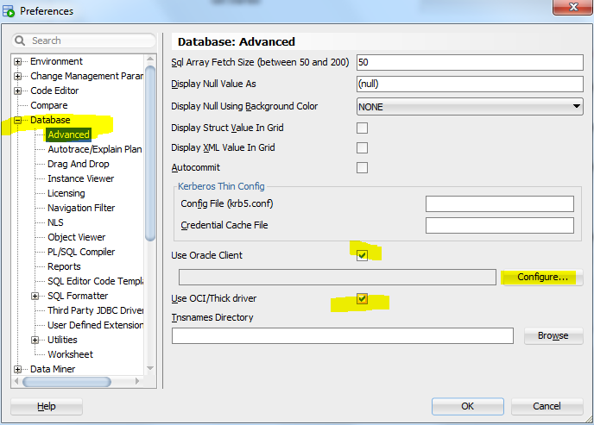

In the drop down box select “Instant Client” and enter the path to where the instantclient folder (it will be in the c:\oracle folder and be identified. Once it is setup click the “Test” button

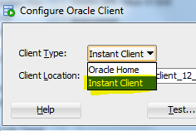

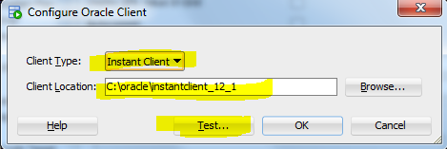

Since the test output is probably behind the open windows, you will need to click OK > then “No” to the restart sqldeveloper dialog and look at the output (pictured below)

The results of your test should look like this: (if it doesn’t then there are troubleshooting things below)

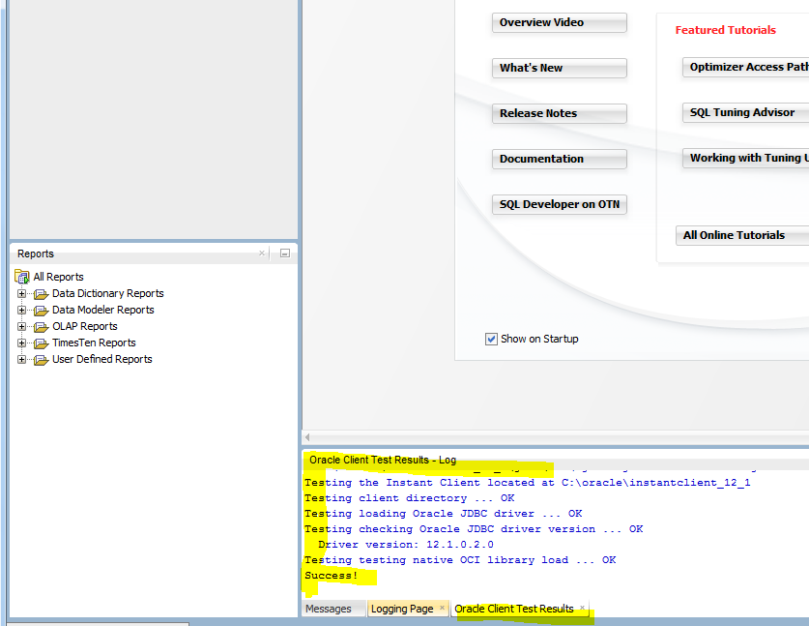

**Troubleshooting:**

If your test results look like the below…

**Error - C:\oracle\instantclient_12_1\jdbc\lib\ojdbc6.jar is not a valid jar file**

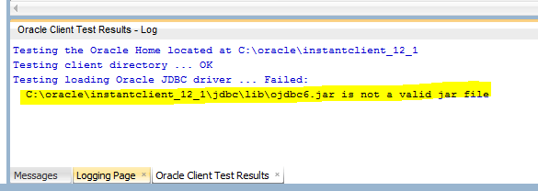

You didn’t select “instant client” from the drop down (as pictured below)

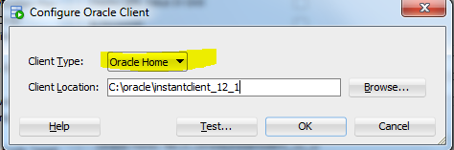

Go back and do that and test again



If your test results look like the below…

Error:

**Error loading the native OCI library**

**The native OCI driver could not be loaded. The system propertyjava.library.path contains the entries from the environment variable PATH. Check it to verify that**

**the expected native library directory C:\oracle\instantclient_12_1 is present and precedes any other client installations.**

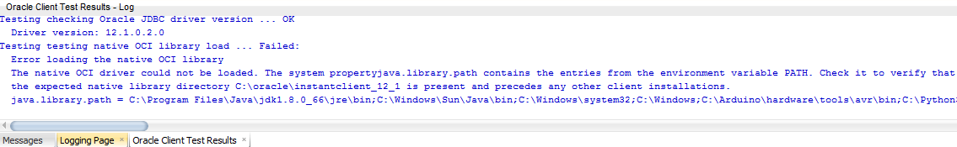

You will need to show the system administrator (technical staff) the error and have them fix the issue.

(C:\oralce\instantclient12_1 is probably not the first listing in the windows system path statement and it needs to be)

**For any other issues – consult with the technical staff at the campus you are on.**